BAM 2
- Create an IAM user with least privilege to deploy infrastructure on the pipeline. Do your best to restrict access, list out the IAM permissions granted, and write out your methodology behind doing so.

IAM Permissions:
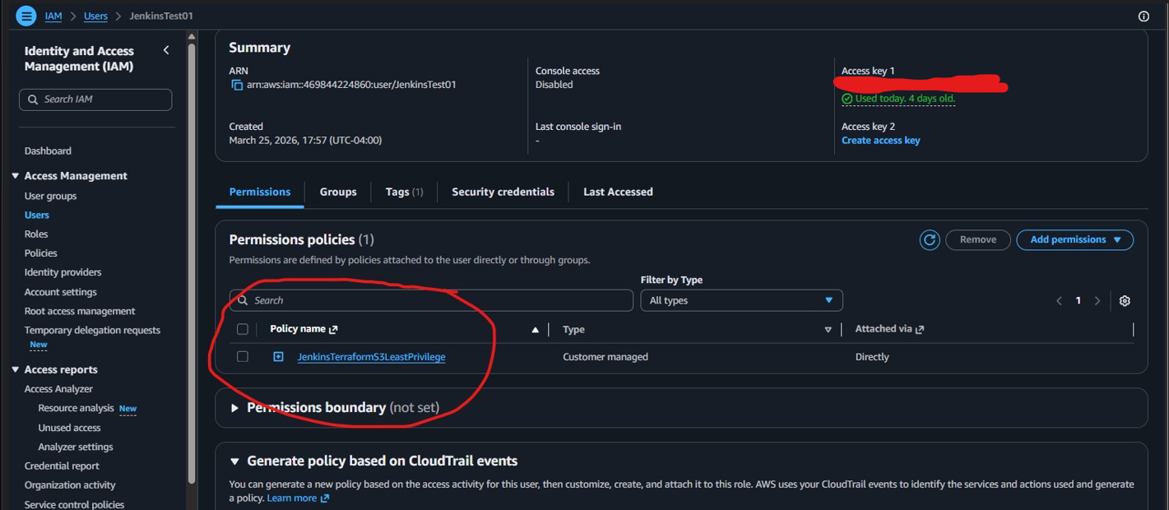

IAM Group:
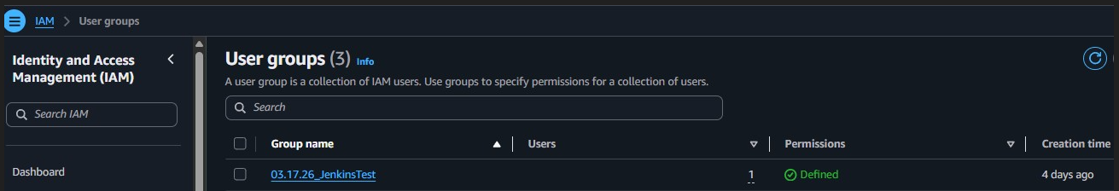
IAM USER: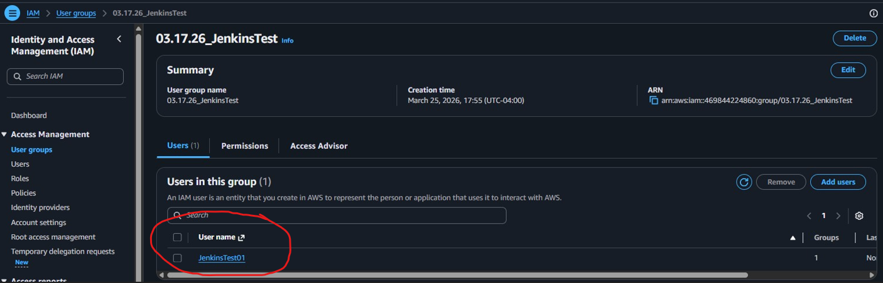

JenkinsTerraformS3LeastPrivilege:
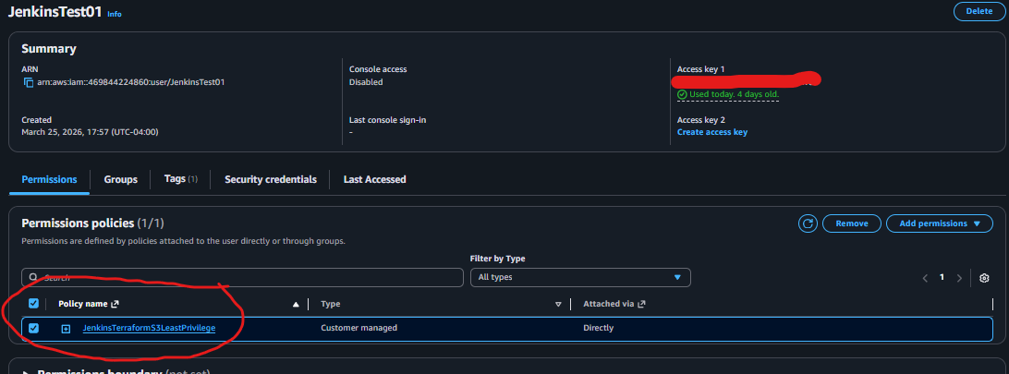

{
"Version": "2012-10-17",
"Statement": [
{
"Sid": "AllowCallerIdentity",
"Effect": "Allow",
"Action": [
"sts:GetCallerIdentity"
],
"Resource": "*"
},
{
"Sid": "AllowBucketList",
"Effect": "Allow",
"Action": [
"s3:ListAllMyBuckets",
"s3:GetBucketLocation"
],
"Resource": "*"
},
{
"Sid": "AllowJenkinsBucketManagement",
"Effect": "Allow",
"Action": [
"s3:CreateBucket",
"s3:DeleteBucket",
"s3:ListBucket",
"s3:GetBucketTagging",
"s3:PutBucketTagging",
"s3:GetBucketPolicy",
"s3:PutBucketPolicy",
"s3:DeleteBucketPolicy",
"s3:GetBucketAcl",
"s3:PutBucketAcl",
"s3:GetBucketVersioning",
"s3:PutBucketVersioning",
"s3:GetEncryptionConfiguration",
"s3:PutEncryptionConfiguration",
"s3:GetLifecycleConfiguration",
"s3:PutLifecycleConfiguration",
"s3:GetBucketPublicAccessBlock",
"s3:PutBucketPublicAccessBlock"
],
"Resource": [
"arn:aws:s3:::jenkins-bucket-*"
]
}
]
}

Results:
I created a dedicated IAM user named JenkinsTest01 for Jenkins and assigned a custom policy named JenkinsTerraformS3LeastPrivilege. I used a least-privilege approach by avoiding broad administrative permissions and limiting the Jenkins user to only the actions required for the Terraform pipeline. Since this pipeline was used to validate, plan, apply, and manage the Jenkins S3 bucket, I restricted access to only the necessary AWS actions instead of granting full account-wide access. My methodology was to identify the resources used by the pipeline, create a custom IAM policy for only those services, test the pipeline, and keep permissions as narrow as possible.

